Dear [Parents/Guardians],
We know our students are amazing, so we’re giving them the opportunity to showcase and celebrate their talents in the world-renowned ICAS competitions this year.
What is ICAS?
ICAS is an online academic competition that gives students the opportunity to challenge their higher order thinking and problem-solving skills in English, Mathematics, Science, Writing, Spelling Bee, and Digital Technologies.
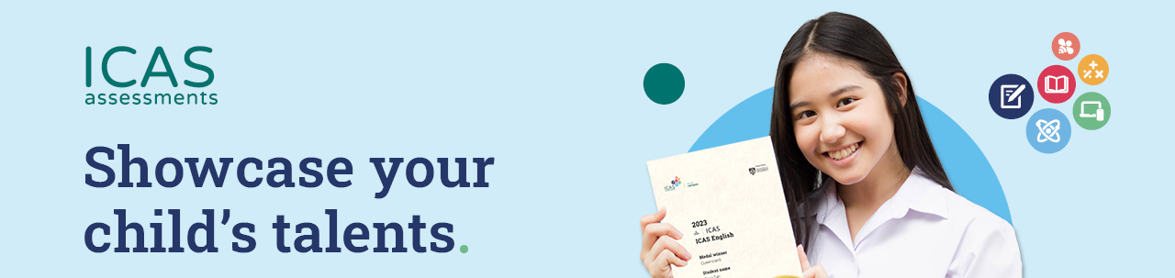
Every student who participates is celebrated and recognised with a printed certificate in each subject area, and an online results report to track development each year. Top performers are eligible for one of the highly coveted ICAS medals.

To learn more about this year’s exciting ICAS competition, visit here

How to participate in ICAS
If you wish to have your child participate in ICAS this year, please:
- Read about ICAS subjects here
- Decide subject areas your child would like to participate in.
- Sign and return the Permission Slip with the required fee included in an envelope marked with your child’s first name, last name, and class.

ICAS results and certificates
All assessments will be conducted online, at school. We will notify you of the date(s) that we will run ICAS assessments, and when your child’s ICAS results are ready. Your child’s ICAS certificates will be delivered to school. Once we have received them, we will present them to your child to bring home. The back of the certificate will show your child’s ICAS results and the login details, “TAP ID and Pin”. Use these to enter the Results Portal

Parent Permission Slip

Permission Slip – please return to [staff member/location in the school] by [DD/MM/YY].
I give permission for my child, _______________________________________, in year _______ to participate in 2026 ICAS.

Please tick:

□ I have read and agree to the ICAS Assessments term and conditions

□ I have enclosed the correct amount to pay for the tests.

Tick the boxes of ICAS subject/s that you are paying for:
Subject | Year |  |  |  |  |  |  |  |  |  | ICAS Official Sitting Dates | Closing Dates | Price
Subject | 3 | 4 | 5 | 6 | 7 | 8 | 9 | 10 | 11 | 12 | ICAS Official Sitting Dates | Closing Dates | Price
Writing |  |  |  |  |  |  |  |  |  |  | Monday, 3 August 2026 to Friday, 7 August 2026 | Wednesday, 22 July 2025 | Rp. 330.000
Mathematics |  |  |  |  |  |  |  |  |  |  | Monday, 7 September 2026 to Tuesday, 15 September 2026 | Wednesday, 19 August 2026 | Rp. 285.000
Digital Technologies |  |  |  |  |  |  |  |  |  |  | Monday, 7 September 2026 to Tuesday, 15 September 2026 | Wednesday, 19 August 2026 | Rp. 285.000
Science |  |  |  |  |  |  |  |  |  |  | Monday, 14 September 2026 to Tuesday, 22 September 2026 | Wednesday, 19 August 2026 | Rp. 285.000
English |  |  |  |  |  |  |  |  |  |  | Monday, 14 September 2026 to Tuesday, 22 September 2026 | Wednesday, 19 August 2026 | Rp. 285.000
Spelling Bee |  |  |  |  |  |  |  |  |  |  | Monday, 22 September 2025 to Tuesday, 26 September 2025 | Wednesday, 19 August 2026 | Rp. 285.000
TOTAL

Signed (Parent signature) _________________________________________

Parent name (please print) _________________________________________

Date: _______________________

